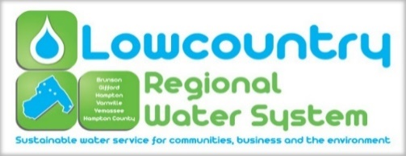

The Lowcountry Regional Water System Commission held a speciall called meeting at 4:00 pm on Thursday, September 30, 2021 in the large conference room at the Hampton County Adminstrative Center in the Town of Hampton, 200 Jackson Avenue East, Hampton South Carolina. All meetings are open to the public (except for information, if any, to be discussed in Executive Sessions) and all interested parties are invited to attend.

Commission Present: Mr. Rocky Hudson, Brunson

Mayor Mitchell, Gifford

Mayor Bilka, Hampton

Ms. Peggy O’Banner, Yemassee

Officers Present: Mr. Brian Burgess, General Manager
Ms. Sara Craven, Secretary

Visitors Present: None

Quorum Met: Yes

1. Call to Order
Chairman Rocky Hudson called the meeting to order at 4:00 pm.

2. Invocation and Pledge of Allegiance
Invocation was given by Jimmy Bilka.
Pledge of Allegiance - Conducted by all.

3. FOIA Compliance Report
As required by Code of Laws of South Carolina, notice of this LRWS Commission meeting was posted prominently in the offices of the Commission at least twenty-four hours in advance. In addition, the local news media and all persons requesting notifications of meetings of the LRWS Commission were notified of the time, date, and place of such meeting, and were provided with a copy of the agenda at least twenty-four hours prior to this meeting.

4. Adoption of the Agenda
Moved by Horney Mitchell, seconded by Peggy O’Banner to adopt the agenda. Motion carried unanimously.

5. New Business
- Resolution 2021-09 Continuance of FY 2020-2021 Operating Budget
Moved by Jimmy Bilka, seconded by Horney Mitchell to approve Resolution 2021-09 Continuance of FY 2020-2021 Operating Budget. Motion carried unanimously.

6. Adjournment
Moved by Jimmy Bilka, seconded by Horney Mitchell to adjourn. Motion carried unanimously. Meeting then adjourned at 4:04 pm.

Respectfully submitted by Sara Craven.

