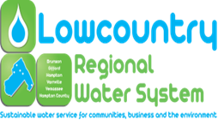

NOTICE OF PUBLIC MEETING

Please note that the Lowcountry Regional Water System Commission will hold a special called meeting immediately after a work training session scheduled for 10:00 am to 2:00 pm on Friday, May 03, 2019 at 201 Lee Avenue, Hampton South Carolina in the downstairs conference room of the Southern Carolina Alliance Office Building. Please note that the work training session may end earlier or later than scheduled. All meetings are open to the public and all interested parties are invited to attend.

AGENDA

1. Call to Order
2. Invocation and Pledge of Allegiance
3. FOIA Compliance Report
4. Adoption of the Agenda
5. New Business
   1. Approval of Terms and Conditions and Acceptance of an Economic Development Administration (EDA) Grant in the Amount of $1,694,000 for the Town of Brunson’s Sewer System Rehabilitation Project.
6. Adjournment