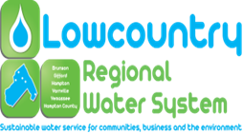

NOTICE OF PUBLIC MEETING

Please note that the Lowcountry Regional Water System Commission is holding a special called meeting at 4:00 pm on Wednesday, October 02, 2019 at 200 Jackson Avenue East, Hampton South Carolina. All meetings are open to the public (except for information, if any, to be discussed in Executive Sessions) and all interested parties are invited to attend.

AGENDA

1. Call to Order
2. Invocation and Pledge of Allegiance
3. FOIA Compliance Report
4. Adoption of the Agenda
5. New Business
   1. Resolution 2019-07 Amendment to Article III Section 1. of the Bylaws of the Lowcountry Regional Water System.
6. Executive Session
   1. Discussion of Matters related to the General Manager’s Performance Evaluation as allowed by SC Code of Laws as Amended, **Section 30-4-70 (a) (1)** discussion of employment, appointment, compensation, promotion, demotion, discipline, or release of an employee, a student, or a person regulated by a public body or the appointment of a person to a public body**;**

**“Upon returning to open session, the Commission may take action on matters discussed in executive session.”**

1. Adjournment